****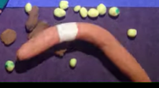

**WACHUSETT GARDEN CLUB PLANT SALE GUIDELINES TO CONTROL SPREADING JUMPING WORMS**

**ANNUAL PLANT SALE: WGC is planned for SATURDAY, MAY 11, 2024 at the THOMAS PRINCE SCHOOL IN PRINCETON.**

The plants sold come from the gardens of our members & friends.

An **invasive worm – Amynthas *spp* – known as Jumping Worm** is known to be here in Massachusetts and many other states. This document provides you with guidelines to reduce the risk of spreading jumping worms at our plant sale. It includes**: how to identify them, how they cause damage, how to determine if you have them, and what to do to control and eliminate them.**

**IMPORTANCE**: The plant sale is our largest source of annual income and funds our community outreach programs at the Thomas Prince School including the new pollinator garden and identification signs of native and invasive plants for the Nature Trail, maintaining the Veteran’s Memorial Garden on the Princeton Common and community educational programs.

**If potential plant buyers are suspect of the quality of our plants, we lose their trust and will have a hard time regaining it. It is critical that we all follow these guidelines when digging up plant donations**.

**If you know you have jumping worms, PLEASE DO NOT donate plants from that**

**garden unless you have removed all soil, inspected the plant and repotted it in sterilized soil.**

**IDENTIFICATION and LIFE CYCLE OF JUMPING WORM**

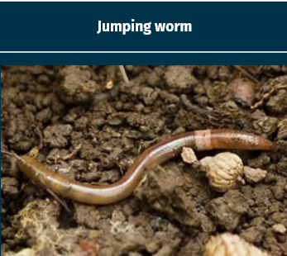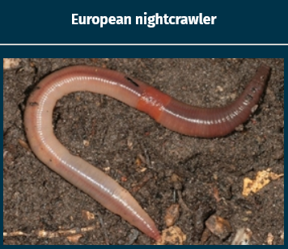

**Clitellum, flush**

**With body**

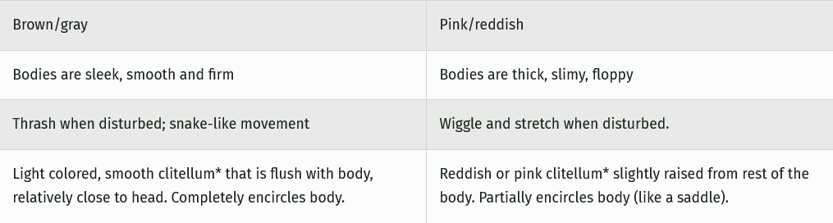

Source: https://dnr.wisconsin.gov/topic/Invasives/fact/jumpingWorm

**HOW DO JUMPING WORMS HURT THE ENVIRONMENT? KNOW THE LIFE CYCLE OF THE JUMPING WORM**

**They are VORACIOUS EATERS** that congregate in large numbers in the top **2-3 inches of the soil**. **They *eat the organic matter*, *leaving coffee-like cast*ings**; depleting nutrients, soil water retention, and make it impossible for roots to take hold.

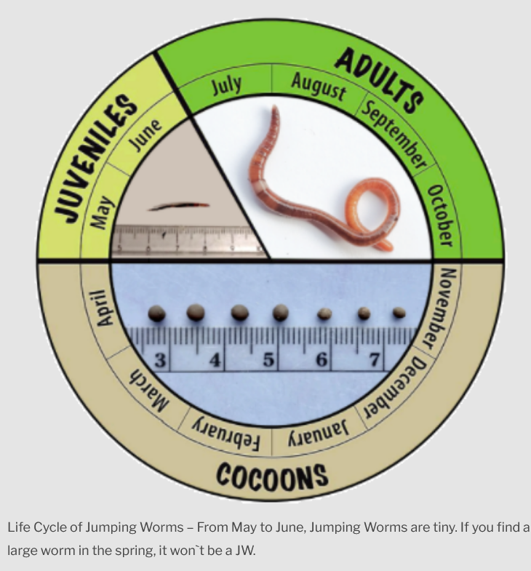Ju

**It takes 60 days for the worms**

**to mature**

**Juveniles**

**Emerge**

**when the**

**temp is 50 degrees.**

J

**HOW TO TEST FOR JUMPING WORMS**

* **Mix 1/3 cup of ground** **yellow mustard seed with 1 gallon of water.**
* Clear a patch of soil. Pour the solution slowly over soil.
* The worms get irritated and will come to the surface.
* **Kill the worms up by placing them in a Ziploc bag in the sun or drop in soapy water.**

**You can DETECT COCOONS by shoveling soil into a pail filled with water. The cocoons will float to the surface.**

**Cocoons live through**

**the winter**

**SOLARIZATION**

**Can be used when you find JW or want to be cautious after you have obtained soil, loam or mulch**

* **Place plastic** or a tarp under **soil, manure, loam, mulch or potting soil** in a **SUNNY LOCATION.**
* **Cover with clear plastic (1.5 to 2 mils thick)* tucking it in tightly so that worms cannot get in or out.**
* **Leave it for 2-3 weeks or until the soil is 104 degrees for 3 days. (You can use rolls of 1 to 4 mil "painter's" plastic)**

STOP THE SPREAD. PREVENTION IS KEY

**INSPECT** your **soil and gardens** **often** for worms & cocoons. Follow their life cycle to identify them.

**BEST PRACTICE: REMOVE Dirt from ROOTS, WASH in a bucket of water to remove cocoons, RINSE in second bucket of water until you think cocoons are removed.**

**Keep bareroots in a plastic bag or repot**

* **ONLY USE** Commercial Compost, Soil or Mulch. **Store in protective container**.
* **When repotting**, place the plant on a tarp or wooden surface to avoid transfer of cocoons or worms.
* **Propagate via seeds and stem cuttings** whenever possible (rather than plant division or root cuttings)
* **Grow seeds**.
* **Arrive Clean, Leave Clean. Clean soil off equipment and tools.**
* **Brush dirt off.** Soak tools **in Soap and Water. Sanitize with 2 tsp Bleach in 1 gallon H2O. Let tools soak for 10 minutes.** Rinse and Dry thoroughly.

**PLANTING TIPS**

**AVOID PLANTING in summer when Jumping Worm are most**

**plentiful.**

**PLANT in the SPRING before Jumping Worms mature.**

**PLANT TREES in the FALL to allow them to establish when**

**Jumping Worm populations start to decline.**

**Plant NATIVE SPECIES that are drought tolerant and have**

**deeper roots.**

**If plants are not doing well, inspect the roots and remove &**

**destroy any Jumping Worms or cocoons.**

**REPORT JUMPING WORMS**

**Report any sightings to** **EDDMapS** (EDDMaps.org) or **iNaturalist** **(iNaturalist.org)**. These are on-line databases and have phone apps. They are checked by state employees who monitor invasive species.

**You can also report them to the MA Department of Agricultural Resources** [**https: //massnrc.org/pests/report.aspx**](https://massnrc.org/pests/report.aspx)

**REPORTING IS CRITICAL by all of us** to provide data to scientists and increase visibility of the invasive species problem and how we can help stop their spread. 2/18/24 page 2