IDENTIFYING and REPORTING INVASIVE PLANTS
The simplest and most important thing to help fight invasive species is to identify what they look like. By knowing what to look for and identifying any new introductions, you can help minimize their establishment and impact.

Invasive organisms frequently spread due to human activities. They can easily be transported on living plants or fresh products such as fruit. Pests can be found in recently killed plant materials such as firewood, lumber, and wooden packing. By not moving these materials over long distances, the spread of pests can be slowed.

It is also important to buy only certified pest-free nursery stock. Some nurseries still sell invasive plants such as Japanese barberry and honeysuckle.

Below are RESOURCES that will help to identify and control invasive species:
- https://www.massaudubon.org/our-conservation-work/ecological-management/habitat-management/invasive-species

- Fish & Wildlife Service Invasive Species Information
- "A Guide to Invasive Plants in Massachusetts". from the Massachusetts Division of Fish and Wildlife

- The Massachusetts Invasive Plants Advisory Group (MIPAG) https://www.massnrc.org/MIPAG/

DATABASES
- www.bugwood.org
- National Invasive Species Information Center (NISIC):
Federal, State, local, and international sources. To find information about invasive species
in your state, type the name of your state into the Search NISIC box at the top left of the page.
There is a column with: What is the Invasive Species Profile
The second item down is: Terrestrial Plants
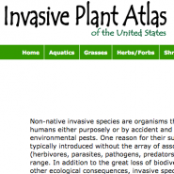
- The Invasive Plant Atlas Of The United States
This Atlas is a comprehensive reference on all the plants species documented to be invasive somewhere in the United States. Each species page includes a county-level range map showing where the plant has been reported to be invasive, along with a detailed plant description and helpful photos. The plant lists unfortunately can’t be sorted by region— to start learning about invasive terrestrial species in Massachusetts, this brief primer on Massachusetts Invasive Plants covers some of the species.

1
REPORT and MONITOR INVASIVE PLANTS
`Another way to record and monitor invasive plants is by using programs that have set up apps to be used by the Smartphone, for example:
EARLY DETECTION and RAPID RESPONSE (EDRR)

https://www.invasivespeciesinfo.gov/what-are-invasive-species
Even the best prevention efforts cannot stop all invasive species. Early detection, rapid assessment, and rapid response are critical defenses against the establishment of invasive populations. Preventing just one new invasion can make a huge difference in preserving an ecosystem and decreasing economic and environmental costs.
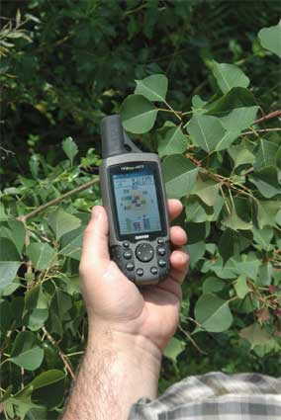
Some smartphone apps can be used to upload images and use GPS (Global Positioning System) data on invasive plants to local or national databases. Maps can be made to locate where invasive plants are and if they are spreading. This can be done in real time.
Interventions can then be started to remove the invasives.

Taking GPS coordinates of Chinese

tallowtree infestation

Photo by: David Moorhead, UGA

These tools are for Citizen Scientists and Professionals and Include:

Citizen Scientist learn how follow guidelines to report invasive plants and become a steward (caretaker) of the environment to keep our earth healthy.
- EDDMapS - Early Detection and Distribution Mapping System
- iMapInvasives
- https://masswoods.org/outsmart (U Mass Amherst)
- https://www.npdn.org/home
- https://www.firstdetector.org/

2

