2021 Garden Club Plant Sale
May 8th, from 9 a.m. to Noon.
The Wachusett Garden Club plant sale will be held at the Thomas Prince School (Rte62) in Princeton.
Start your garden off right with a selection of plants, donated by the members and friends of the Wachusett Garden Club. A wide selection of perennials and annuals for sun and shade will be available.

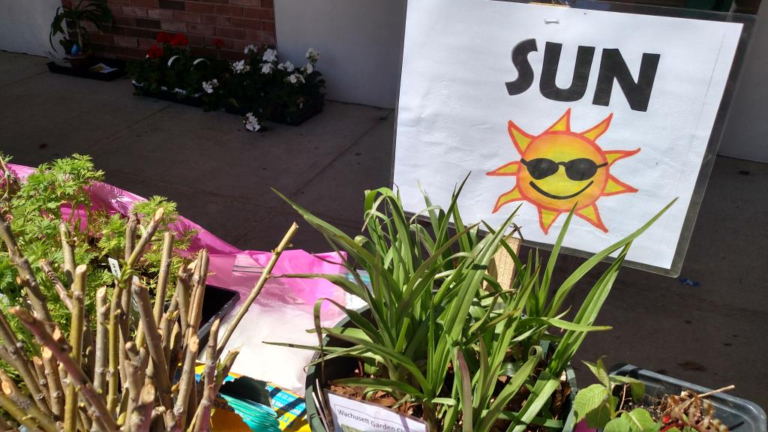
May 8th, from 9 a.m. to Noon.

WGC Plant Sale
Thomas Prince School,
170 Sterling Rd,
Princeton, MA 01541

The Wachusett Garden club promotes the study of horticulture and the love of gardening, to protect our environment, and encourage conservation. Through the knowledge and skills of our members, we offer community programs to benefit our towns and their residents, and promote a spirit of well-being.
Visit us at: http://www.wachusettgardenclub.org
Or scan the QR code below using your phone camera to connect to our website:

