Spring is here and the snow has finally melted...we are all getting excited about the upcoming gardening season! Something we all look forward to is the Wachusett Garden Club Plant Sale, Saturday, May 8th from 9 am-12 pm at the Thomas Prince School. A selection of beautiful plants donated by members and friends of the club includes perennials, herbs, and annuals for sun and shade.
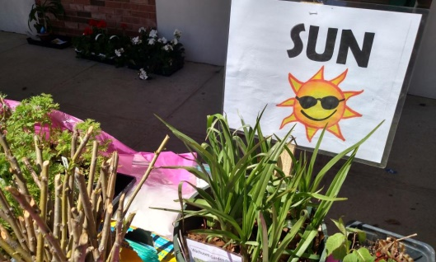
If you have plants to contribute, please dig up, pot, and label plant divisions as soon as possible so the plants will have time to settle in and recover.
If you need help getting plants ready or have plants to donate,
Please email us at: onlinewgc@yahoo.com
Members of the Wachusett Garden Club will contact you.
Ask us if you need help to Identify Plants, WGC members will be glad to help!
Proceeds from the plant sale benefit the local community, through our civic activities and philanthropic causes. Our members and volunteers plant and maintain the Princeton Memorial Garden in the center of the Town. We support local conservation and environmental organizations.
Like us on Facebook!! AND THANK YOU!!
Visit us at: http://www.wachusettgardenclub.org
Or scan the QR code below using your phone camera to connect to our website:

